Exoplanet Outline

1. Introduction
   1. Recent endeavors (GAIA, Kepler, TESS)
2. Formation of Exoplanets
   1. Protoplanetary Disc
   2. Accretion of material
3. Detection Techniques
   1. Gravitational wobble (Hot Jupiters)
   2. Transit events

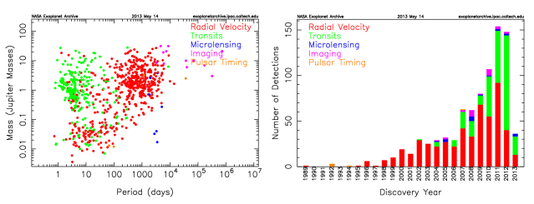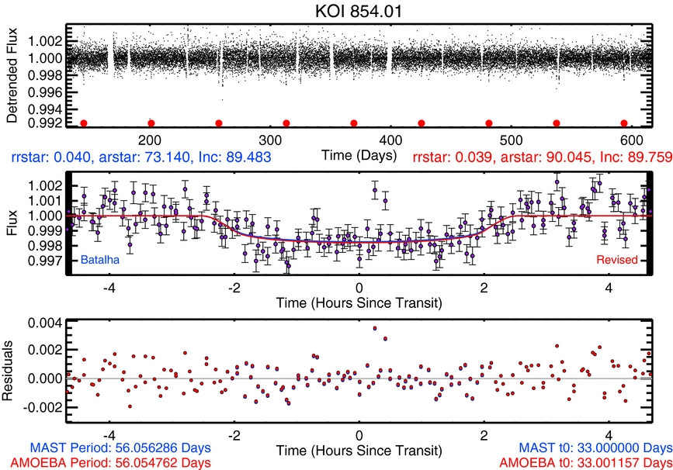

1. Star type vs. Life

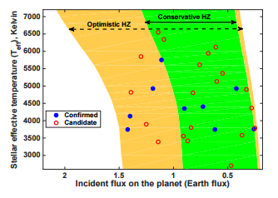

* 1. Giants/ Super giants die fast
  2. White dwarfs too old
  3. Mostly main sequence stars

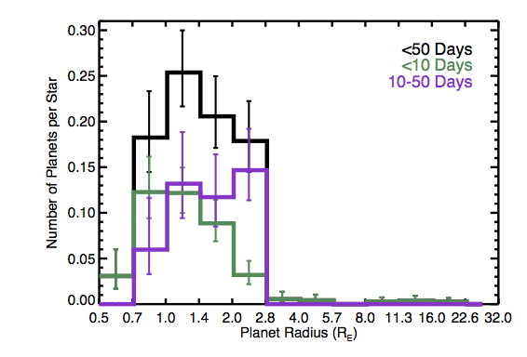

* 1. Atmospheric composition

1. M-(dwarf) Stars and Earth-like planets
   1. Problems with this type
   2. Atmospheric composition
2. Conclusions
   1. My take
   2. Current understanding
   3. Future endeavors